Talkies Short Film Commission 2018: Application Form
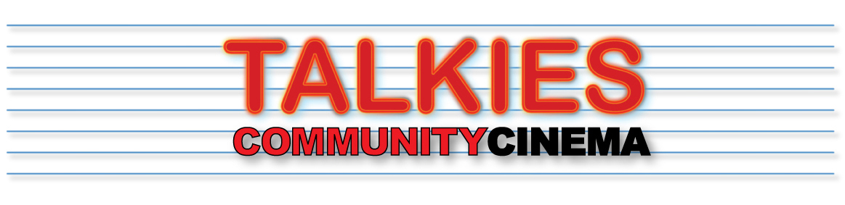
Deadline Sunday October 1st

Please read the outline brief carefully (see PDF).
Email finished forms (or any queries) to info@talkies.org.uk

1. NAME OF APPLICANT/S:

2. CONTACT DETAILS:
Email:
Tel/Mob no.
Social media:

3. PREVIOUS WORK:
Website/ Vimeo/Youtube page:

4. BRIEF RESUME OF RELEVANT EXPERIENCE (250 WORDS OR LESS):

5. OUTLINE PROPOSAL FOR SHORT FILM: (UP TO 250 WORDS AND ANY SUPPORTING IMAGES)
Please note that this is an expression of interest, we do not expect these to be fully formed ideas yet. Each filmmaker, if shortlisted, will have a chance to meet with the Talkies team to discuss their ideas and hone them before the final deadline.

6. IF YOU ARE SHORTLISTED, WHAT QUESTIONS WOULD YOU WANT ANSWERED BY TALKIES OR SHORT SIGHTED CINEMA?

