Talkies Short Film Commission 2019: Application Form
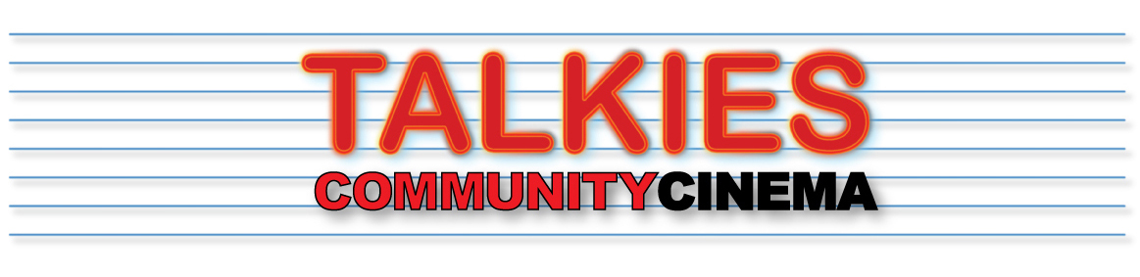
Deadline Sunday July 1st 2018
Please read the outline brief carefully (see PDF).
Email finished forms (or any queries) to info@talkies.org.uk

1. NAME OF APPLICANT/S:

2. CONTACT DETAILS:
Email:
Tel/Mob no.

SOCIAL MEDIA AND WEBSITE LINKS (we will use these links for promoting your film)
FACEBOOK
TWITTER
INSTAGRAM
OTHER

3. EXAMPLES OF PREVIOUS WORK:
Website/ Vimeo/Youtube page:

4. BRIEF RESUME OF RELEVANT EXPERIENCE (250 WORDS OR LESS):

5. OUTLINE PROPOSAL FOR SHORT FILM: (UP TO 250 WORDS)
- Capture our attention and get to the shortlisting stage!
Please note that although we do not expect ideas to be finalised, there should be a clear essence of the story you want to tell and the characters that will tell it. This will be your chance to fire our imagination and get you shortlisted.
Shortlisted filmmakers will have a chance to meet with the Talkies team to discuss their ideas and hone them before the final deadline.

6. PRODUCTION
see note above
This section might include a draft script, any cast or crew that you may have in mind, mood boards, storyboards, or anything that will give us a good understanding of how you will make your idea become a reality.

