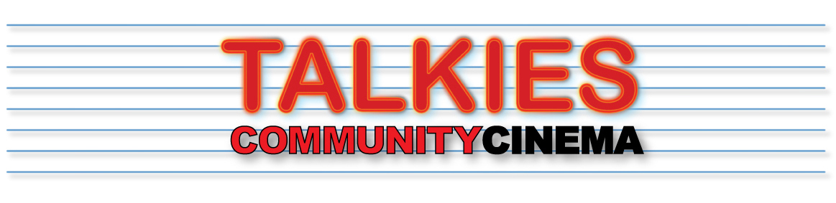
www.talkies.org.uk
OVERVIEW:
Talkies is a not-for-profit, volunteer-led, pop-up cinema operating in Palmers Green and surrounding areas of North London.
We have been established for five years and hold about 30 screenings each year in a range of venues around the area. Amongst these are short film programmes, in collaboration with Short Sighted Cinema, who partner with us on Talkies Short Film Commissions.
Each year we use the income surplus from our programme to re-invest in emerging talent in the industry. The commissions are open to anyone – you do not have to live in our area – but each of the films MUST be shot in the area. When developing your idea it will be helpful to you to research the area so you can understand the setting.
The shorts premiere is part of Talkies’ HERE FILM FESTIVAL (link to festival 2019) - our annual celebration of writers, directors and actors that live in our part of London .

You don't need to live in our area to qualify. However, your film MUST be shot in the area.
Each successful applicant will receive £500, paid in part in advance with the remainder after the premiere. We also offer up to £100 for marketing of your short film in festivals after the Talkies premiere.
You can use this together with other funding sources to finance your short film. However, credits must include a single screen acknowledging “Commissioned by (Talkies logo) in collaboration with (Short Sighted Cinema logo). Talkies/SSC will provide the artwork for this screen.
We STRONGLY ADVISE that you read the brief carefully and the videos of previous film makers, which should give you all the information you need and some sense of how the Talkies’ commissions are more than the £500 award….

There are eight million stories in the London suburbs; this will be just four of them!
SHORT FILM COMMISSION – OUTLINE BRIEF:
This commission is for four film makers to produce a short film around the theme “HERE” based in and around Palmers Green, North London .
For example:
- What are the interesting narratives of life in our area today?
- How are we changing?
- What captures the spirit of our time?
We want you to be creative in your approach, perhaps injecting some humour into your work that helps people to see themselves or their community in a new light.
The films should be no more than 20 mins long.
Screen-ready copies of films should be completed and presented by March 8th 2020.

APPLICATIONS:
Applications will be in three stages

STAGE 1 – APPLICATION – SEPTEMBER 15th 2018 (revised date)
At this stage we will be looking for interesting ideas, which, whilst not necessarily being fully formed, will resonate with and make a good contribution to the festival. We will also want to see that you have already made short films of good quality. If you succeed at this stage more detail will be needed at the next stage.

STAGE 2 – DEVELOPMENT DISCUSSIONS – FROM SEPT 30TH
Up to 8 applicants will be short listed and invited to discuss their ideas further with Talkies and Short Sighted Cinema. At this stage we will want to help you to flesh out your proposal, offer ideas for locations and suggest contacts. After development discussions you will submit your final proposal by October 13th.

STAGE 3 – COMMISSION – 27TH OCT
Once you have been informed about your commission and we have sorted out the agreement, you will have until March 8TH 2020 to complete and submit your film. We expect the shoot to be completed by December 2018. During this period we will offer what help we can to support your work.

ADVICE AND SUPPORT
Talkies Community Cinema provide a range of support for your short film, through mentorship and local facility.
Successful applications will go through a short-listing stage before the final pitches are agreed, during which we will offer you some guidance to the local area to help hone your ideas.
DIVERSITY
We in a diverse community and we hope to see a diverse cast and crew for films that we commission.

MENTORS
The HERE Film Festival short film commission is supported by the mentorship of industry professional and award-winning filmmakers. Successful applicants will be assigned a mentor for their project, who will provide a variety of feedback and advice depending on the project. This usually focuses on script rewrites, structure and shot lists, before the shoot begins.
Examples of mentors this year are:
- Marc Issacs, director, writer and documentary maker
- Christine Lalla, TV and feature director and writer
- Ian Barnes, TV director and Oscar nominated short film maker...
- Bruce Goodison, director and writer
- Jason Sutton, writer TV and film, including shorts
LOCATIONS:
During the initial application stage, we do not expect you to have finalised locations, however we do expect you to show an active interest in the locality and to have made a visit to understand the environment in which your film will be set.
We have previously commissioned films that make use of local venues such as the Ruth Winston Centre (for example as Smear, The Problemless Anonymous) , local landmarks (Ballade of the New River Path, Platform 1) , Shops (The Record Detective Agency, Approval Needed ), streets (Date with an Enfield, Cul de Sac, Another Man, Approval Needed,) parks (Sunday Worship, Clanker Man) and houses (for our Cockroaches, Cleared)

LOCAL ASSISTANCE
Talkies Community Cinema has a large following in Palmers Green and the surrounding areas, with many enthusiastic helpers, extras and local guide
We will appoint a Talkies co-ordinator as your interface for our support for your film shoot. We can organise extras for your film (within our demographic), as well as local unit bases for cast & crew, offered by members of the Talkies audience.
TECHNICAL SUPPORT
The main emphasis will be on you gathering around you the crew you need, but Talkies can link you to some technical support, including fixers and runners, stills/BTS photographers, make-up artists etc....
EXHIBITION AND PROMOTION
Each film we commission must premiere at the HERE Film Festival (March 2020), where we exhibit your film on a large Talkies' screen to a public audience. In 2018 and 2019 the audience size was 200 (see photos). We anticipate that you will then be entering your film for other events, festivals and screenings, in which case we will offer an additional £100 for entry fees. You may also want to upload it straight to Vimeo/Youtube – the choice is yours. We expect that within a year we will be able to link to a web version on our Commissions webpage.

