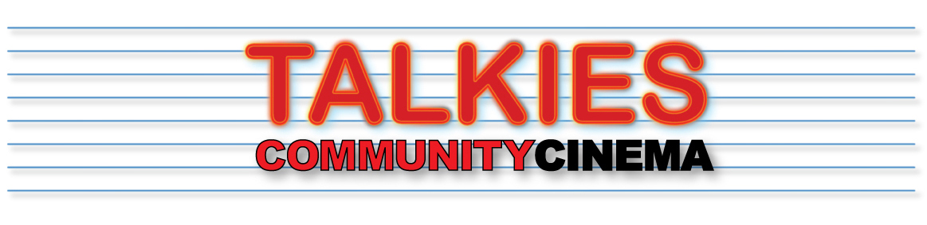
TALKIES HLF SHORT FILM COMMISSION 2021
Application form
Submission deadline midday 1st November 2021
Before applying, please carefully read the outline brief and “Stories of Enfield” summary.
Email completed forms (or any queries) to info@talkies.org.uk

1. NAME OF APPLICANT/S:

2. CONTACT DETAILS:
Email:
Tel/Mob no.

SOCIAL MEDIA AND WEBSITE LINKS (we will use these links for promoting your film)
FACEBOOK:
TWITTER :
INSTAGRAM :
OTHER:

3. EXAMPLES OF PREVIOUS WORK:
Website/ Vimeo/Youtube page/s:

4. BRIEF RESUME OF RELEVANT EXPERIENCE AS A DIRECTOR, FOCUSING ON:
- Relevant experience and good quality previous work, particularly documentary
- Working to a brief
- Experience in and enthusiasm for collaborative working
- The production standards you will bring to the project
- Working to time and budget
- Managing production risks

