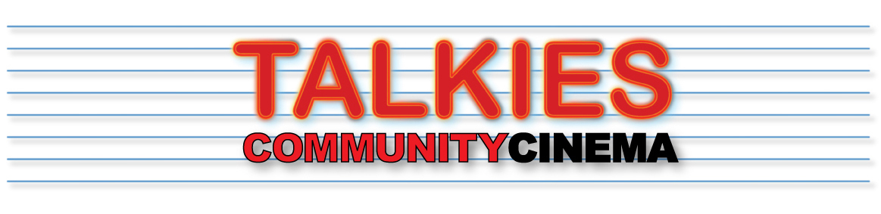
www.talkies.org.uk
OVERVIEW:
Talkies is a not-for-profit, volunteer-led, community cinema operating in Palmers Green and surrounding areas of North London.
We have been established since 2012 and prior to covid held about 30 screenings each year in a range of venues around the area. Our programme focuses mainly on British independent and specialist film, which includes short film format. You can see our back catalogue here.
The commissions are open to anyone – you do not have to live in our area – but each of the films MUST be shot in the area. When developing your idea it will be helpful for you to research the area so you can understand the setting.
The Shorts will premiere as part of Talkies’ annual programme of events.

Each successful applicant will receive £500, paid in part in advance, with the remainder when the film is delivered after its final edit.
We also offer up to £100 for marketing of your short film in festivals after the Talkies premiere.
You can use this together with other funding sources to finance your short film. However, credits must include an acknowledgement in the opening screens and a single screen at the end using a logo image that we will provide.
We STRONGLY ADVISE that you read the brief carefully and watch the videos of previous film makers and the filmmaker interview video, which should give you all the information you need and some sense of how the Talkies’ commissions are more than the £500 award….

TALKIES SHORT FILM COMMISSION – OUTLINE BRIEF:
After a gap of two years, we are re-launching our Talkies’ Shorts Commissions to be screened in 2023.
This commission is for up to four film makers to produce a narrative short film around the theme “HERE” based in and around Palmers Green, North London.
For example:
- What are the interesting narratives of life in our area today?
- How are we changing?
- What captures the spirit of our time?
We want you to be creative in your approach, perhaps injecting some humour into your work that helps people to see themselves or their community in a new light.
The films should be no more than 20 mins long.
Screen-ready copies of films should be completed and presented before February 28th 2023.

APPLICATIONS:
Applications will be in three stages
STAGE 1 – SUBMISSION USING THE APPLICATION FORM – August 5th 2022
At this stage we will be looking for interesting ideas, which, whilst not necessarily being fully formed, will resonate with and make a good contribution to the short film premiere. We will also want to see that you have already made short films of good quality. If you succeed at this stage more detail will be needed at the next stage. We will carry out our assessments during August and contact our shortlisted applicants in early September.
STAGE 2 – DEVELOPMENT DISCUSSIONS – FROM SEPT 19th
Up to 8 applicants will be short listed and invited to discuss their ideas further with us. At this stage we will want to help you to flesh out your proposal, offer ideas for locations and suggest contacts. After development discussions you will submit your final proposal by October 7th.
STAGE 3 – COMMISSION – 14TH OCT
Once you have been informed about your commission and we have sorted out the agreement, you will have until February 28th 2023 to complete and submit your film. We expect the shoot to be completed by December 2022 to allow time for post production. During this period we will offer what help we can to support your work.

ADVICE AND SUPPORT:
Talkies Community Cinema provide a range of support for your short film, through mentorship and local facility.
Successful applications will go through a short-listing stage before the final pitches are agreed, during which we will offer you some guidance to the local area to help hone your ideas.
DIVERSITY:
We live in a diverse community and we hope to see a diverse cast and crew for films that we commission.

MENTORS:
The short film commissions are supported by the mentorship of industry professional and award-winning filmmakers. Successful applicants will be offered a mentor for their project, who will provide a variety of feedback and advice depending on the project. This usually focuses on script rewrites, structure and shot lists, before the shoot begins.
Examples of mentors this year are:
- Christine Lalla, TV and feature director and writer
- Ian Barnes, TV director and Oscar nominated short film maker
- Bruce Goodison, director and writer
- Jason Sutton, writer TV and film, including shorts
LOCATIONS:
During the initial application stage, we do not expect you to have finalised locations, however we do expect you to show an active interest in the locality and to have made a visit to understand the environment in which your film will be set.
We have previously commissioned films that make use of local venues such as the Ruth Winston Centre (for example in Smear, The Problemless Anonymous), local landmarks (Ballade of the New River Path, Platform 1) , Shops (The Record Detective Agency, Approval Needed), streets (Date with an Enfield, Cul de Sac, Another Man, Approval Needed, Jilted) parks (Sunday Worship, Clanker Man) and houses (for our Cockroaches, Cleared)
LOCAL ASSISTANCE:
Talkies Community Cinema has a large following in Palmers Green and the surrounding areas, with many enthusiastic helpers, extras and local guides.
We will appoint a Talkies co-ordinator as your interface for our support for your film shoot. We can organise extras for your film (within our demographic), as well as local unit bases for cast & crew, offered by members of the Talkies’ audience.

TECHNICAL SUPPORT:
The main emphasis will be on you gathering around you the crew you need, but Talkies can link you to some technical support, including fixers and runners, stills/BTS photographers, make-up artists etc....
EXHIBITION AND PROMOTION:
Each film we commission must premiere within the Talkies programme, where we will exhibit your film on a large Talkies' screen to a public audience. In 2018 and 2019, before covid restrictions, the audience size was 200 (see photos). We anticipate that you will then be entering your film for other events, festivals and screenings, in which case we will offer an additional £100 for entry fees. You may also want to upload it straight to Vimeo/Youtube – the choice is yours. We expect that within a year from the premiere we will be uploading your film to the Talkies YouTube channel with a link on our Commissions webpage.

Please note that we have already commissioned two documentaries for 2022/3. If you are interested in documentary making, please send us a brief expression of interest which we can come back to in 2023.

